**CIRRIG App Pages**

The CIRRIG app has four main pages: Title, Home, Weather, and Settings

**Title page**

The title page is briefly displayed when the app starts up while new weather data is being downloaded. Once the download is finished, the title page will transition to the home page. Clicking on the screen anywhere will also force a transition to the home page.

**Home page**

The home page is the main display page. This page displays irrigation recommendations for seven production situations (three different plant sizes for’ jammed’ containers and four different plant sizes for spaced containers) that cover the typical range of situations you would likely find in the container nursery. The irrigation run times displayed on the Home page use the same CIRRIG calculations used in the website version of CIRRIG and are based on FAWN weather from the past 24-hour period. See Basic Concepts.

At the top of the home page the user can change four important factors to acquire a new set of irrigation recommendations:

1) **Container size** – Toggle between trade #1 or #3 containers.

2) **Rain (inch)** – Input the amount of rain received at nursery during the past 24-hour period. The amount overrides FAWN rainfall amount. If it rained at the nursery but not at the FAWN station, only enter the depth of rain that was beneficial. For example, if it rained early in the past 24-hour period, before significant water loss, you might consider not inputting this rain whereas if rain fell late in the day you would.

3) **Irrigation rate (inch/hour)** – Allows the user to change the irrigation rate if it varies in the nursery.

4) **Irrigation capture** – select the icon that best describes the plant’s ability to capture irrigation water. The icons correspond to the options on the website version of CIRRIG:

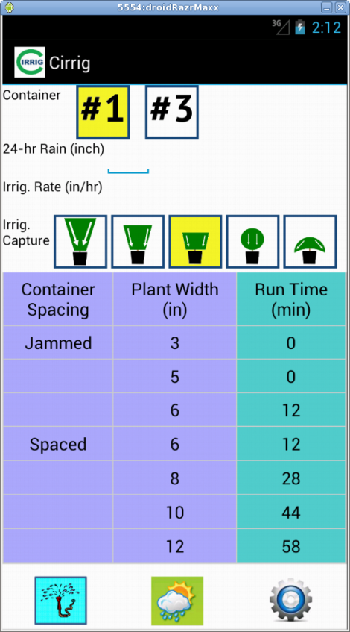 = “Neg”,  = “Nil”,  = “Low”,  = “Med”,  = “High”

If the water-capturing ability of the plant is unknown, selecting “nil” or “low” will provide more conservative (higher) irrigation recommendations. See Basic Concepts.

The default settings for the four factors on the home page are displayed in the Settings.

**Weather page**

The Weather page displays FAWN weather data used to calculate irrigation recommendations by CIRRIG. The top line in red font is the weather data specifically used for the irrigation run times displayed on the home page. Weather data for the past seven calendar days is also displayed below to provide recent weather history.

Other features:

1) Forecast – Create a link to the user’s weather website of choice

2) FAWN – Link to the FAWN website

**Settings page**

The Settings page displays the current settings used to generate the irrigation recommendations displayed on the home page. The user can change one or more of these settings and save the values as defaults.

FAWN weather station

When “Use GPS” is on, the closest FAWN station to the user’s current location will be selected. You can select another station by tapping the current station and selecting from the list of available FAWN stations.

A few notes on the container factors:

1**) Container diameter (inch)** – Containers come in a range of diameters so the user can input the actual diameter of containers used in the nursery including container diameters that would be classified as #2 or #5 containers.

2) **Container spacing (inch)** - There is no one spacing all growers use when containers are spaced out. The user can input the spacings typically used in the nursery if they differ from the ‘factory’ defaults.

3) **Spacing arrangement** – User toggles between offset and square arrangement.

4) **Plant canopy density** - This is a factor not found on the website version of CIRRIG. Plant canopy density is used to describe the compactness of the foliage. Loose, open plant canopies would have a low density and well-shaped, tight canopies would have a high density. Plant canopy density and plant width are used to estimate the amount of leaf surfaces that directly affect the rate of evapotranspiration (water loss).

5) **Irrigation rate (inch/hour)** – The default irrigation rate used for making irrigation recommendations. This rate can be changed on the home page but will revert to the default whenever the app is restarted.